SEARCH ARRAY IN AN ARRAY

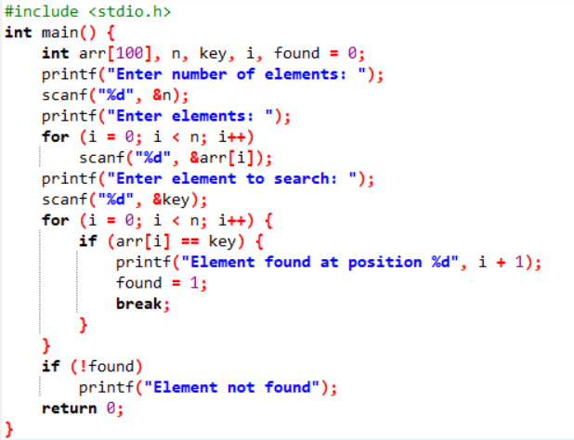

OUTPUT:

